ITM University Gwalior
School of Computing and Intelligent Systems
Project-Based Learning (PBL)
Mini Project Report — Submission Format

Course: Data Analytics Using Python
Course Code: CSL0312
Program: B.Tech. CSE (Artificial Intelligence & Machine Learning)
Semester: III Section:
Academic Session: July–Dec 2026
Project Details
Project Title: __Analysing the Association of Age and Sex with Diabetes Occurrence: An Exploratory Data Analysis Using the CDC Diabetes Health Indicators Dataset____________________________________________________________________
Domain (as per Section 6): Healthcare____
Team Leader Name & Roll No.: ______Anvesha Singh (BETN1AI25111)____________________________________________
Team Member Name & Roll No.: _____Priya Kanshana (BETN1AI25108)_____________________________________________
Team Member Name & Roll No.: _______Jampalli Anyasree (BETN1AI25120)___________________________________________
Faculty Mentor: ____________________Dr.Sanjay Jain________________________________________
Date of Submission: _____________14-10-2026________________________________

1. Introduction & Problem Statement
Introduction
Diabetes is a major health concern that affects people of different age groups. Studying how diabetes occurrence varies with age, sex, and other health-related factors can help us understand patterns in health survey data.
In this project, Python is used to analyse the CDC Diabetes Health Indicators dataset through Exploratory Data Analysis (EDA). The analysis focuses on the relationship between age and sex and the recorded diabetes status. It also examines selected health indicators, including Body Mass Index (BMI), high blood pressure, and high cholesterol.
The project uses data analysis techniques such as descriptive statistics, data visualisation, and chi-square tests of independence. Cramér’s V is used to understand the strength of the associations identified. These methods help present the patterns in the dataset clearly without assuming that one factor directly causes another.
Problem Statement
The project aims to examine how recorded diabetes status varies across different age groups and between sexes. It also investigates whether diabetes status is associated with BMI categories, high blood pressure, and high cholesterol in the dataset.
The analysis is carried out using Python libraries for data handling, visualisation, and statistical analysis. The findings are based on the available survey data and are intended to identify patterns and associations rather than predict diabetes or establish cause-and-effect relationships.

2. Dataset Description & Source
Dataset Description
The project uses the CDC Diabetes Health Indicators dataset. It contains health-related information collected through a survey and is used to explore patterns associated with diabetes status.
The dataset contains 253,680 records and 22 columns, consisting of 21 input features and one target variable. The features include demographic information, health indicators, and lifestyle-related factors.
The main variables considered in this project are:
- Age: Represents the respondent’s age group.
- Sex: Records the respondent’s sex using numerical codes.
- BMI: Represents Body Mass Index.
- HighBP: Indicates whether high blood pressure is reported.
- HighChol: Indicates whether high cholesterol is reported.
- Diabetes_binary: The target variable used to examine recorded diabetes status.
In the target variable, 0 represents no diabetes, while 1 represents prediabetes or diabetes. Therefore, the results are interpreted according to the dataset’s original coding.

Dataset Source
The dataset was obtained from the UCI Machine Learning Repository. It is publicly available for research and data analysis.
Dataset name: CDC Diabetes Health Indicators
Source: UCI Machine Learning Repository
Dataset link: https://archive.ics.uci.edu/dataset/891/cdc+diabetes+health+indicators
The dataset was loaded into Python for analysis using the ucimlrepo library. Pandas was used to organise and inspect the data before performing exploratory data analysis and statistical tests.
Type of Dataset: ☑ Public ☐ Private ☐ Self-Collected
Number of Records: _____ 2,53,680
Number of Attributes/Columns: _22______________
- Records: 253,680 — more than 500.
- Attributes/columns: 22 — more than 5.
- Missing values: 0 — no missing values found.
☑ Dataset meets minimum quality criteria (Section 7)
Brief description of attributes/columns:
The dataset contains 22 columns, including 21 input features and one target variable. The attributes cover demographic details, health conditions, and lifestyle-related factors. They include Age, Sex, BMI, HighBP, HighChol, physical activity, smoking status, general health, and other health indicators. The target variable, Diabetes_binary, records whether the respondent falls into the dataset’s no-diabetes category or its prediabetes/diabetes category.
The dataset contains more than 500 records and more than 5 attributes. The initial quality check found no missing values in any column. Therefore, it meets the minimum record, attribute, and missing-value criteria specified in the template.

3. Data Cleaning & Preprocessing
Data Cleaning & Preprocessing
The dataset was checked to understand its structure, data types, missing values, duplicate records, and unique values in each column. These checks helped assess the quality of the data before performing exploratory data analysis.
The dataset contains 253,680 records and 22 original columns. The missing-value check showed that there were no missing values in the columns. The dataset also contained 24,206 duplicate rows, which were identified during preprocessing. These duplicate rows were counted but not removed in the notebook.
The BMI column was further categorized into four groups: Underweight, Normal, Overweight, and Obese. This additional column, named BMI_Category, was used for comparing the target category across BMI groups. The data was then used for further analysis and visualization.
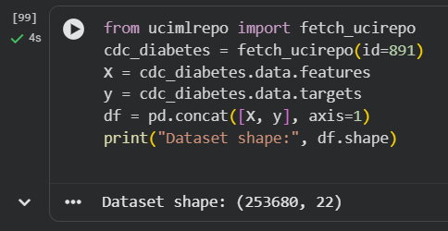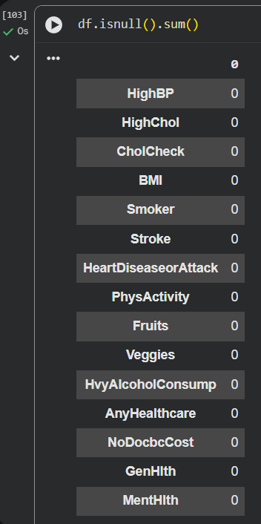
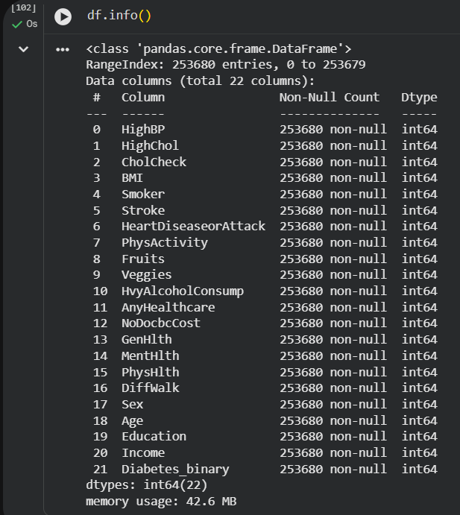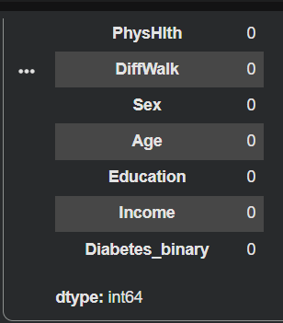

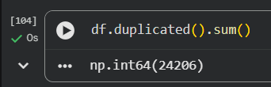
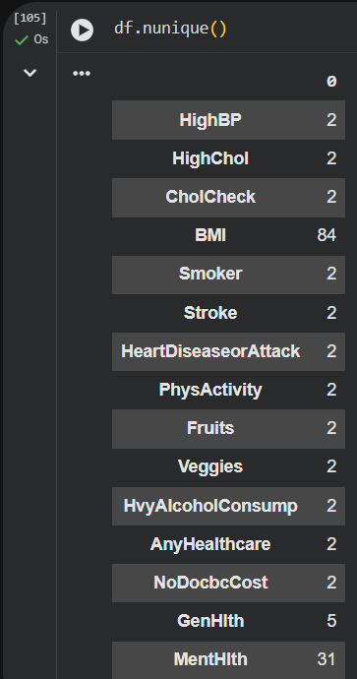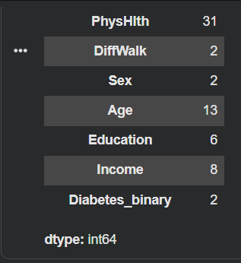
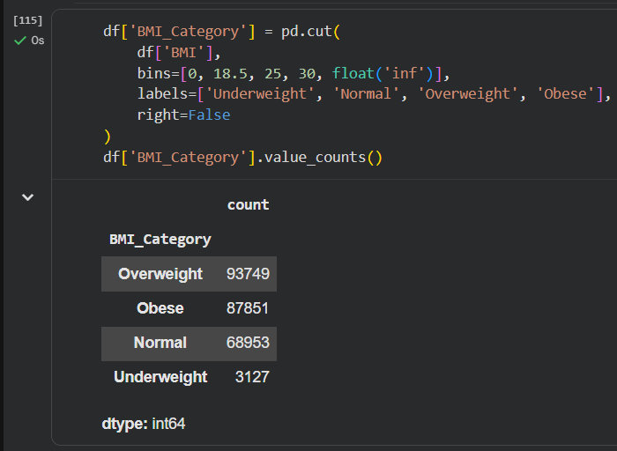

4. Exploratory Data Analysis (EDA)
4.1 Overall Target Distribution
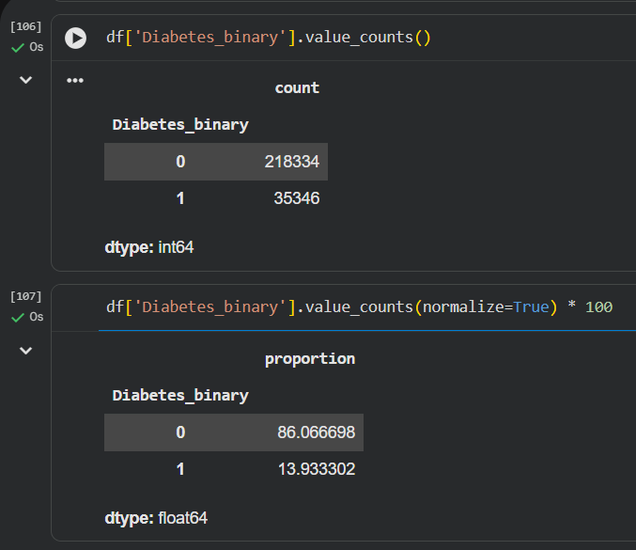
The target distribution shows that 218,334 records (86.07%) belong to category 0, while 35,346 records (13.93%) belong to category 1. This indicates that category 0 represents the majority of the dataset. Category 1 represents prediabetes or diabetes in the dataset.
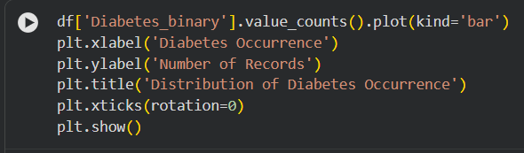
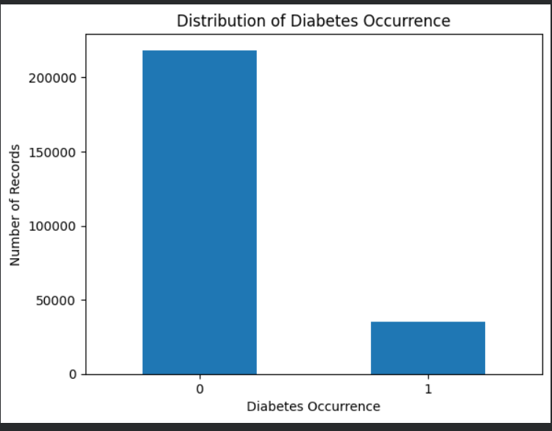

4.2 Age-Group Analysis
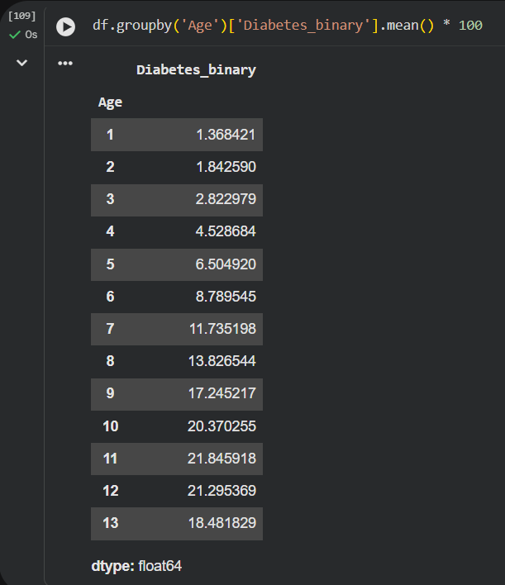
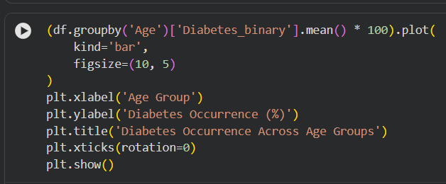

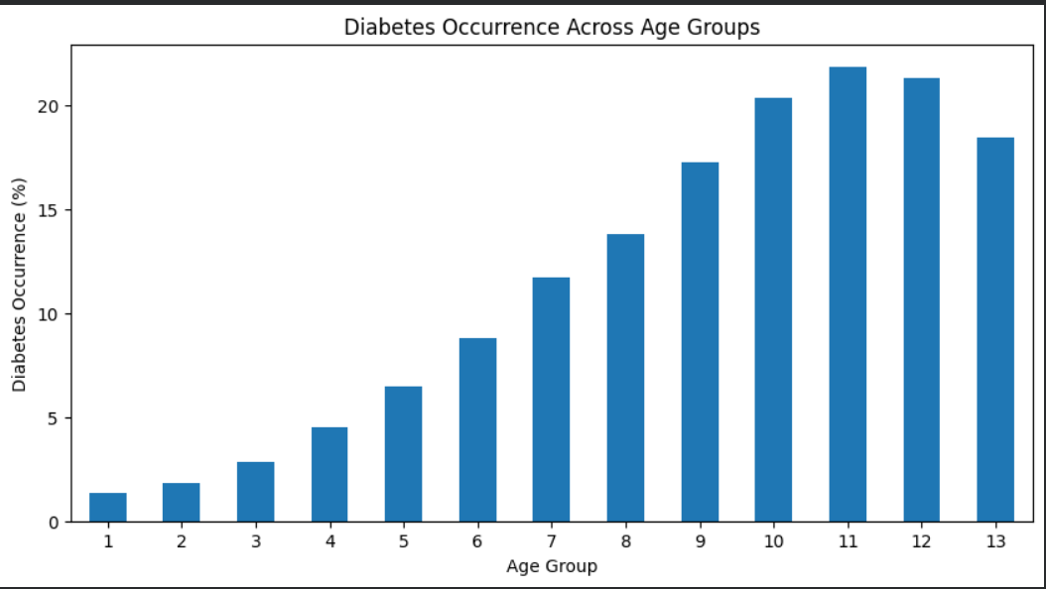
The analysis shows a variation in diabetes occurrence across the different age groups. The percentage generally increases across the age groups, rising from approximately 1.37% in the youngest group to a peak of approximately 21.85% in age-group code 11. It then decreases slightly in the oldest groups.
This pattern indicates an association between age group and the occurrence of prediabetes or diabetes in the dataset. However, the analysis shows an association and does not establish that age directly causes diabetes.
4.3 Sex-Based Analysis
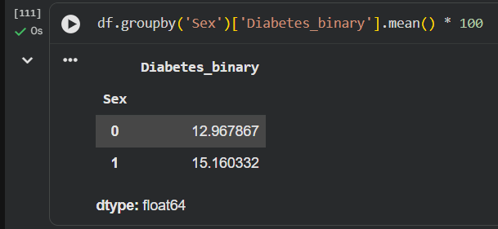
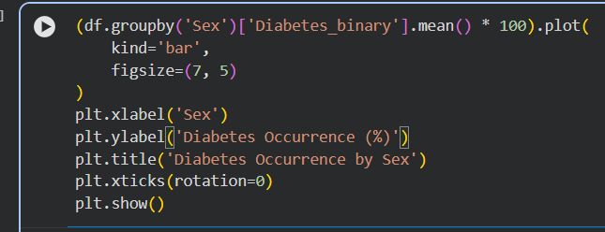
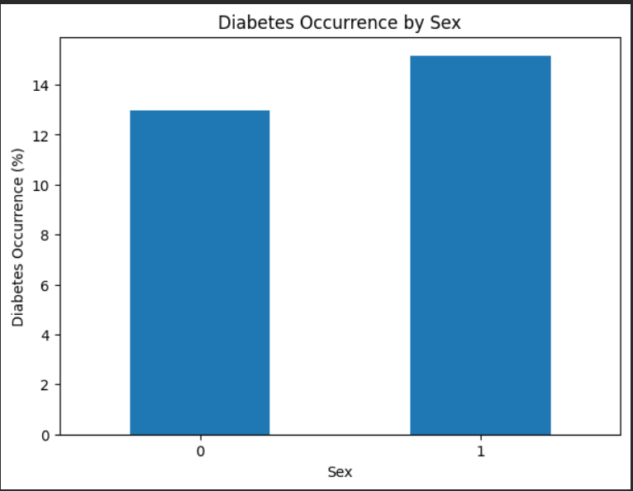
The analysis shows that the percentage of prediabetes or diabetes occurrence is approximately 12.97% for Sex code 0 and 15.16% for Sex code 1. Therefore, the percentage is higher for Sex code 1 than for Sex code 0 in this dataset.
This comparison indicates a difference in occurrence between the two sex categories. However, it does not establish a cause-and-effect relationship. The results describe the dataset and should not be generalized to all individuals without further investigation.

4.4 BMI Analysis

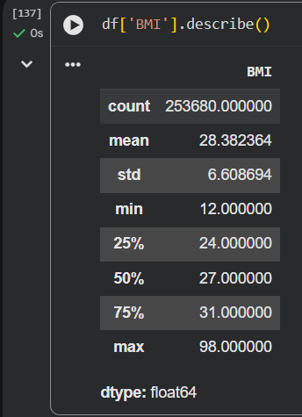
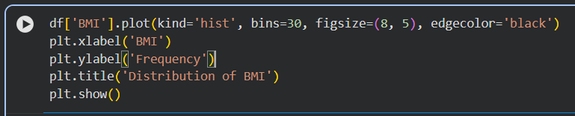

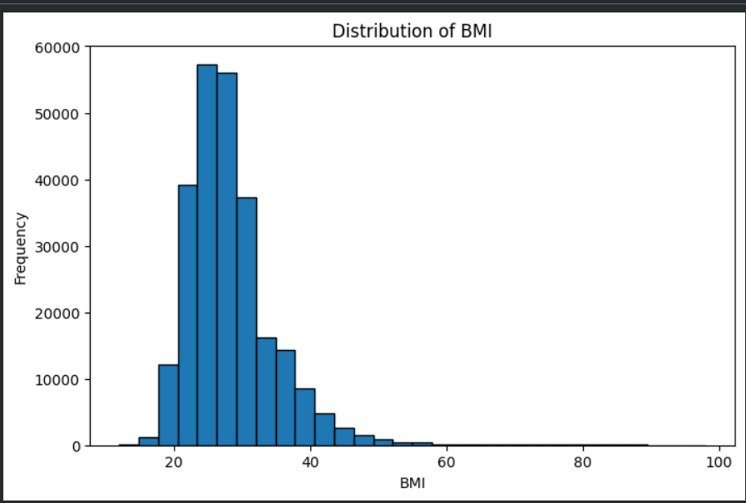
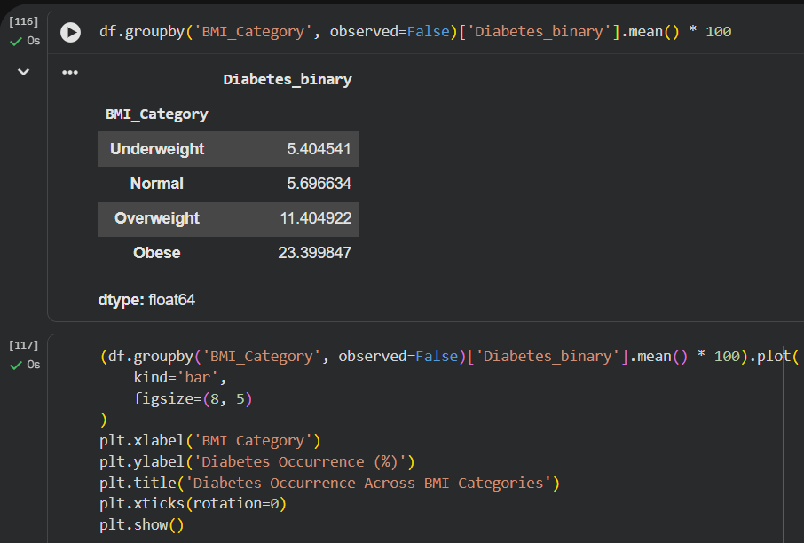

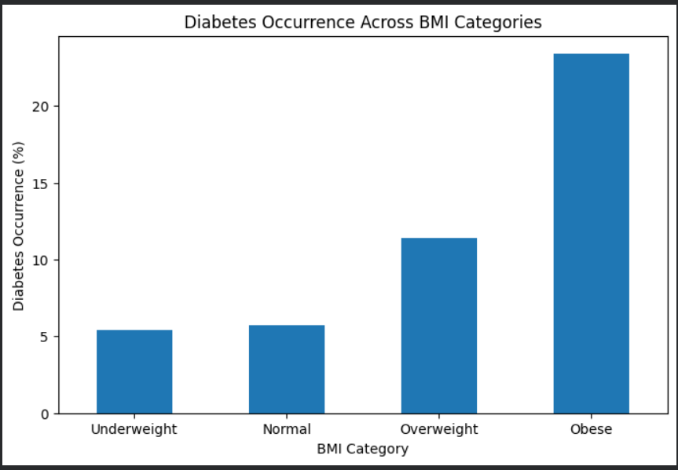
The BMI summary shows a mean BMI of 28.38 and a median of 27. The BMI distribution graph helps examine how BMI values are spread across the dataset.
When comparing BMI categories, the percentage of prediabetes or diabetes occurrence increases from 5.40% in the underweight category to 23.40% in the obese category. The overweight category shows an occurrence of 11.40%, while the normal category shows 5.70%.
These results indicate an association between BMI category and prediabetes or diabetes occurrence in the dataset. They do not establish that BMI directly causes the outcome.

4.5 High Blood Pressure Analysis
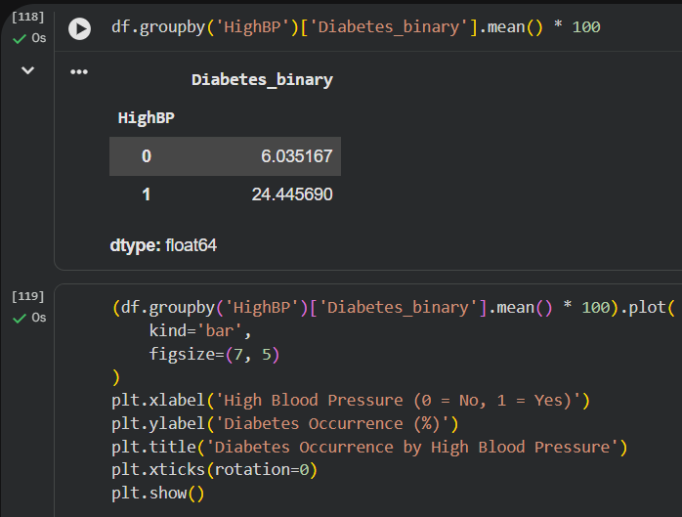
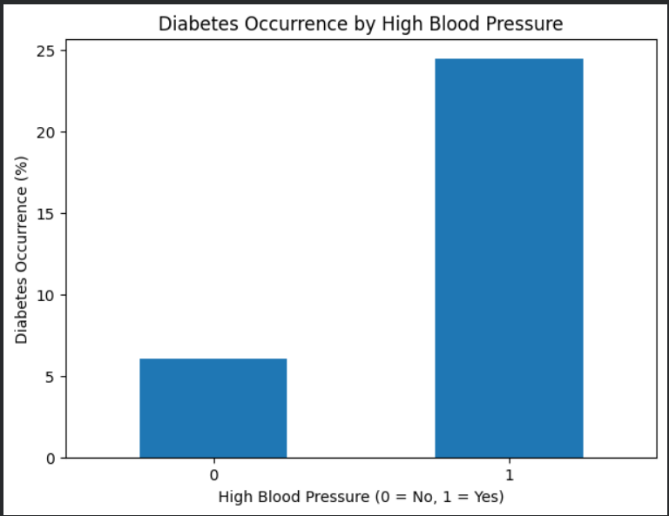

The analysis shows that the percentage of prediabetes or diabetes occurrence is approximately 6.04% among records without high blood pressure and 24.45% among records with high blood pressure.
The higher percentage in the second group indicates an association between high blood pressure and prediabetes or diabetes occurrence in this dataset. However, these results do not establish a cause-and-effect relationship.
4.6 High Cholesterol Analysis
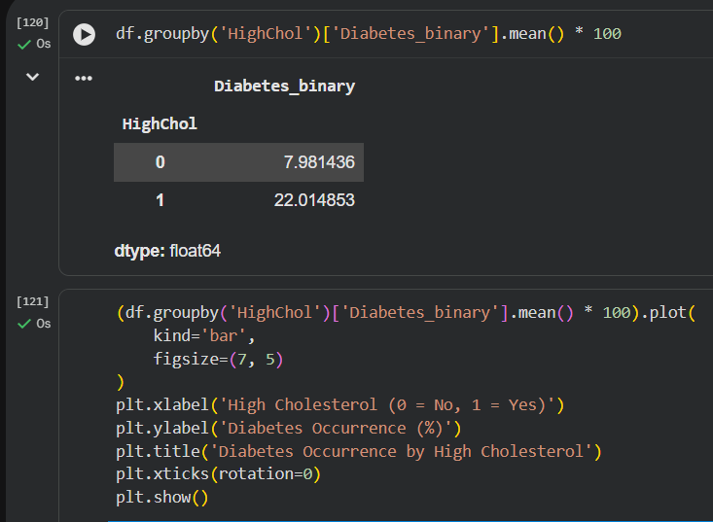
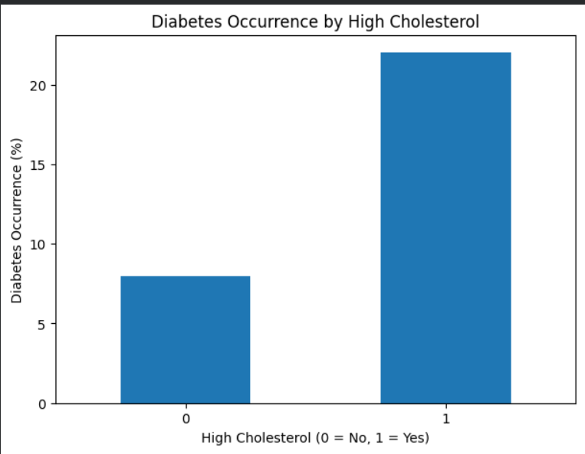
The analysis shows that the percentage of prediabetes or diabetes occurrence is approximately 7.98% among records without high cholesterol and 22.01% among records with high cholesterol.
The percentage is higher among records with high cholesterol, indicating an association between high cholesterol and prediabetes or diabetes occurrence in this dataset. However, this comparison does not establish a cause-and-effect relationship
5. Data Visualization & Observations
The visualizations provide a clear overview of the patterns observed in the CDC Diabetes Health Indicators dataset. The target distribution shows that 86.07% of records belong to category 0, while 13.93% belong to category 1, which represents prediabetes or diabetes.
The age-group graph shows that the percentage of prediabetes or diabetes occurrence generally increases across age groups, reaching its highest value of approximately 21.85% at age-group code 11. The sex-based comparison shows a higher percentage for Sex code 1 (15.16%) than for Sex code 0 (12.97%).
The BMI analysis shows a higher percentage of prediabetes or diabetes occurrence in the obese category (23.40%) compared with the other BMI categories. Similarly, the graphs for high blood pressure and high cholesterol show higher percentages among records with these conditions: 24.45% for high blood pressure and 22.01% for high cholesterol.
Overall, the visualizations highlight differences in prediabetes or diabetes occurrence across age groups, sex categories, BMI categories, and health indicators. These findings describe associations within the dataset and do not establish cause-and-effect relationships.

Explanation of Category Codes
In the dataset, Diabetes_binary is the target variable, where 0 represents no prediabetes or diabetes and 1 represents prediabetes or diabetes. The Sex variable uses 0 for female and 1 for male. The Age variable is coded into 13 age groups, ranging from code 1 (18–24 years) to code 13 (80 years or older).
For the HighBP and HighChol variables, 0 represents No and 1 represents Yes. The BMI_Category variable contains four groups: Underweight, Normal, Overweight, and Obese. These categories help compare the percentage of prediabetes or diabetes occurrence across different groups.

6. Statistical Analysis (Basic)
6.1 Chi-Square Test of Independence
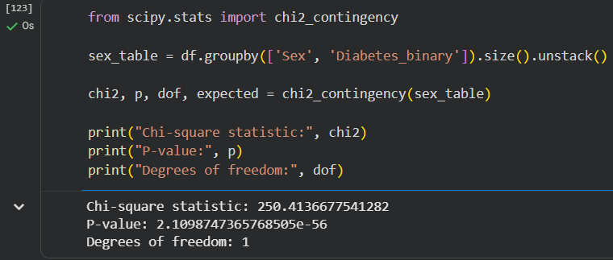
The chi-square test results show p-values below 0.001 for all five variables. Therefore, the null hypothesis of independence is rejected for each comparison at the 5% significance level. This indicates statistically significant associations between diabetes occurrence and sex, age group, high blood pressure, high cholesterol, and BMI category in this dataset.
However, statistical significance alone does not indicate the strength of an association or establish a causal relationship.
6.2 Cramer’s V
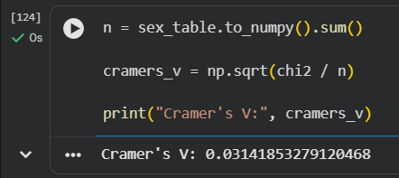
The Cramer’s V results show that the strength of association varies across the selected variables. High blood pressure has the highest Cramer’s V value (0.2631), followed by BMI category (0.2097), high cholesterol (0.2003), and age group (0.1862). Sex has the lowest value (0.0314).
These results suggest that high blood pressure has the strongest association among the variables examined, while sex has the weakest. Although the chi-square tests indicate statistically significant associations, the Cramér’s V values show that the strength of these associations is generally limited.
Conclusion of statistical analysis
The chi-square tests identified statistically significant associations between diabetes occurrence and all five selected variables. Cramér’s V provided additional information about the strength of these associations. Together, these methods offer a more complete understanding of the relationships observed in the dataset, without implying causation.

7. Key Insights & Interpretation
The exploratory data analysis identified several patterns in the association between age, sex, and prediabetes or diabetes occurrence in the CDC Diabetes Health Indicators dataset. Additional comparisons with BMI, high blood pressure, and high cholesterol provided further insights into the distribution of the target variable.
- Age group: The percentage of prediabetes or diabetes occurrence generally increased across age groups, reaching approximately 21.85% at age-group code 11. This indicates differences in occurrence across age groups, although the percentage decreased slightly in the oldest groups.
- Sex: The occurrence percentage was approximately 12.97% for females (code 0) and 15.16% for males (code 1). The difference suggests an association between sex and the target variable in this dataset.
- BMI category: The obese category showed the highest occurrence percentage at 23.40%, compared with 11.40% for overweight, 5.70% for normal, and 5.40% for underweight. This indicates a difference in occurrence across BMI categories.
- High blood pressure: The occurrence percentage was 24.45% among records with high blood pressure, compared with 6.04% among records without it. This was the largest difference among the two-category health indicators examined.
- High cholesterol: Records with high cholesterol had an occurrence percentage of 22.01%, compared with 7.98% among records without high cholesterol. This indicates a difference between the two groups.
- Statistical findings: Chi-square tests showed statistically significant associations between the target variable and all five examined variables (p < 0.001). Cramér’s V values ranged from 0.0314 for sex to 0.2631 for high blood pressure, showing that the strength of association differed across variables.
Interpretation: The findings show that prediabetes or diabetes occurrence varies across age groups and sex categories, and also across BMI categories and selected health indicators. These results help address the project problem statement by describing the observed associations in the dataset. However, the analysis does not establish causation, and the findings should be interpreted within the limitations of the available data.

8. Conclusion & Future Scope
Conclusion
This project, titled “Analysing the Association of Age and Sex with Diabetes Occurrence: An Exploratory Data Analysis Using the CDC Diabetes Health Indicators Dataset,” was carried out to examine how prediabetes or diabetes status varies across age groups and between males and females, while also exploring selected health indicators.
Using Python, the project analysed the distribution of the target variable, compared occurrence percentages across demographic groups, and explored associations with BMI, high blood pressure, and high cholesterol. The visualizations showed differences in occurrence across these groups. Chi-square tests indicated statistically significant associations between the target variable and the five examined variables, while Cramér’s V helped assess the strength of those associations.
The findings fulfil the project's main analytical purpose by identifying and interpreting patterns in the dataset through descriptive statistics, visualization, and statistical testing. However, the results represent associations within the available data and do not establish cause-and-effect relationships.
Future Scope
The project can be extended in the following ways:
- Joint age and sex analysis: Examine age-group patterns separately for males and females to understand whether the observed distributions differ between these groups.
- Further group-wise comparisons: Explore combinations of age, sex, and selected health indicators using cross-tabulation and appropriate statistical tests.
- Improved statistical interpretation: Include effect sizes and, where appropriate, confidence intervals to support clearer interpretation of observed differences.
- Additional health indicators: Extend the exploratory analysis to other documented variables in the dataset, subject to the project scope and faculty approval.
- Enhanced visualization: Develop clearer comparative graphs and summary tables to communicate findings effectively.
The future work will remain focused on exploratory data analysis, visualization, and statistical association testing, consistent with the approved scope of the Data Analytics Using Python course. Any substantial change to the approved topic or methodology will be discussed with the faculty mentor.
9. References
- UCI Machine Learning Repository. (n.d.). CDC Diabetes Health Indicators. University of California, Irvine. https://archive.ics.uci.edu/dataset/891/cdc+diabetes+health+indicators
- Center for Disease Control and Prevention. (n.d.). Behavioral Risk Factor Surveillance System (BRFSS) prevalence data. CDC Data. https://data.cdc.gov/Behavioral-Risk-Factors/Behavioral-Risk-Factor-Surveillance-System-BRFSS-P/dttw-5yxu
- Center for Disease Control and Prevention. (n.d.). BRFSS glossary and methodology. https://data.cdc.gov/Survey-Data/Behavior-Risk-Factor-Surveillance-System-BRFSS-Glo/5amh-5sx3
- McKinney, W. (2010). Data structures for statistical computing in Python. In Proceedings of the 9th Python in Science Conference (pp. 56–61). https://doi.org/10.25080/Majora-92bf1922-00a
- Virtanen, P., et al. (2020). SciPy 1.0: Fundamental algorithms for scientific computing in Python. Nature Methods, 17, 261–272. https://doi.org/10.1038/s41592-019-0686-2

10. AI Tool Usage Declaration
☐ No AI tools were used in this project.
☑ AI tools were used, as detailed below:

AI Tool Used | Purpose (e.g., debugging, documentation) | Extent of Use / Section Applied
ChatGPT | Assistance with report documentation, wording, and explanation of analytical findings. | Report sections including Introduction, Dataset Description, Data Cleaning and Preprocessing, EDA, Data Visualization and Observations, Statistical Analysis, Key Insights, Conclusion, and References. The project analysis and results should be reported based on the actual Python notebook outputs.

11. Project Links & Deliverables
GitHub Repository Link: _______________________________________________________
Python Notebook (.ipynb) File Name: ____DATA ANALYTICS FILE_________________________________________
PBL Report File Name: ______DATA ANALYTICS FINAL REPORT____________________________________________
Confirm that the GitHub repository includes the code, notebook, and a PBL report as required.
☐ GitHub repository includes code, notebook, and a PBL report and README

12. Report Structure Checklist (Section 8 Compliance)
S. No. | Report Section (as per Section 8 format) | Included (✓)
1 | Title Page | ✓
2 | Introduction & Problem Statement | ✓
3 | Dataset Description & Source | ✓
4 | Data Cleaning & Preprocessing | ✓
5 | Exploratory Data Analysis (EDA) | ✓
6 | Data Visualization & Observations | ✓
7 | Statistical Analysis (Basic) | ✓
8 | Key Insights & Interpretation | ✓
9 | Conclusion & Future Scope | ✓
10 | References | ✓
13. Declaration by Student(s)
I/We hereby declare that this Mini Project Report is our own original work, prepared using publicly available/open datasets. All sources of data, references, and AI tool assistance have been duly acknowledged. I/We understand that any instance of plagiarism in code or report will attract strict academic action, as per Section 15 of the PBL guidelines.
Team Leader Signature: _____________________________________________
Team Member Signature(s): _____________________________________________
Date: ____________________________________________________________

14. For Faculty Use Only — PBL Final Report Evaluation
Evaluation Component B — PBL Final Report Submission | Mid-Term (PBL Based): 10 Marks (Section 10 of PBL Guidelines)
Evaluation Criteria | Max Marks | Marks Awarded
Data Cleaning & Preprocessing | 2
Exploratory Data Analysis (EDA) | 2
Visualization & Observations | 2
Statistical Analysis | 2
Insights, Interpretation & Conclusion | 2
Total (out of 10) | 10
Faculty Remarks:

Faculty Mentor Signature: _____________________________________________

Date: ____________________________________________________________

